Thuc Tran and Shane Kelly
LEDraw
Project Overview:
Our project , LEDraw, starts a live video stream from the user's web cam and allows them to draw on the frame with an LED light that we made. The LED light can be turned on and off, which allows the user to draw on the image just like they would with a pen or pencil. The color that is drawn with is decided by the average color of a certain set of pixels in the frame and there are many buttons on the frame that can be 'pushed' with the LED that change the pen size and clear the drawing.

Results:
What we ended up with was actually pretty cool. It is a drawing platform where you can draw on yourself or paint over the frame to create a blank canvas. In order to choose a color, you look around you for inspiration and paint in the colors of the world around you. In the example below, we painted the scenery of a house with 4 items, a black wallet, a colorful magazine, a blue cup, and an orange (which, surprisingly, was orange). In order to paint with a color of something around you, simply put the object in the view of the red box at the bottom left hand corner. Here is a beautiful piece of artwork that we created and the real-world things that we used to draw it.
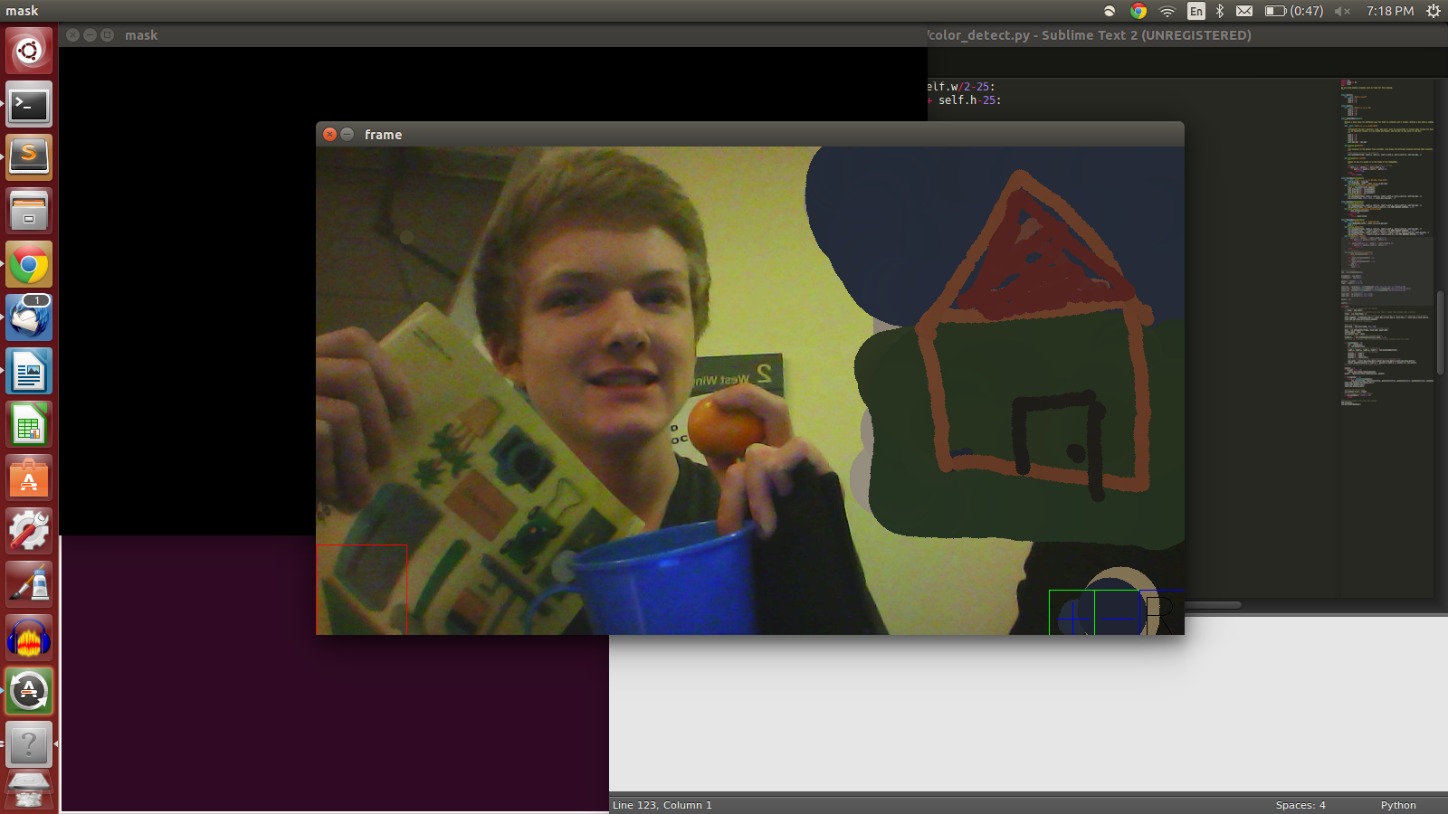
In addition to being able to use the colors that surround you in the world, you are also able to do a few other functions. We are also able to clear the screen by having a pointer directed within the reset box in the lower right corner. We are also able to change the radius of the drawing pointer by going to the box with a plus or minus signs. Our final product ended up being fun and interactive!

Implementation:
Everything in our code is based on class of some type. The light that is detected by OpenCV has a class, the pointer that you draw with has a class, and each of the boxes and buttons that corresponds to some command has a class. Each of these classes has x and y positions, most of them have width and height, and some have state characteristics that control what command they are currently executing.

Many of these classes interact with each other in order to create the interactive effects of LEDraw. The best example of this is the collaboration between the Pointer class and the RadiusBox. We created a function called 'inframe()' that checks to see if the Pointer class is within the RadiusBox and, if so, then the radius of the Pointer should be changed. The Pointer has similar interactions with the ResetBox, which allows the user to clear the screen of any drawings when the Pointer is 'inframe()' of the ResetBox.

One large design decision that we had to make was how to actually draw on the camera frame and in what fashion we should store this draw data. We eventually decided that the most efficient way to do this would be to make a list that stored a collaboration of class characteristics from Pointer, Light, and RadiusBox. The list was structured as a list of lists, where each sublist contained the x position, y position, radius, and color of any circle that needed to be drawn on the image. This solution ended up being by far the most efficient of any design that we tried and also was implemented in only a few lines of cleanly written code.

Reflection:
One thing that went very well from a process point of view was how well we collaborated. We used github very well and always pushed everything that we had worked on after a meeting. We could work on things in parallel, commit them, push them to github, and then merge our two versions. This made the project development process very fluid and much less painful than we had expected.

One thing that largely impeded our progreess was actually deciding on what project we should pursue. We originally had an idea that was largely computationally based and would have been more of an addition to the comp_art project than a new object oriented project. We got feedback to go down a more interactive-based path, which was very helpful, but then we got stuck deciding what the actual features of our final project would be. We eventually decided, but we lost half of the time that we had just deciding on what to work on. We can only imagine what our final project would have looked like if we had an additional week to develop it.

